BUSINESS QUESTIONS AND VISUALIZATION REPORT
Visualization development is the process of transforming raw data into meaningful charts, graphs, cards, and interactive dashboards. In our project, we use Power BI to visualize smartphone usage data, including screen time, addiction levels, sleep patterns, gaming, social media usage, and notifications. These visualizations make the data easier to understand, allow users to compare different categories, and help identify important patterns and trends in digital usage.
Business Questions and Visualization
“Business and visualization process involves defining business questions, selecting relevant data, choosing suitable charts, developing interactive visualizations in Power BI, analyzing the results, and presenting meaningful insights.”
1. what is the average daily screen time by gender?
Visualization: Column chart showing average daily screen time for Male, Female and Other.
- Screenshot of visualization:

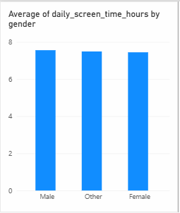

2. what are the different addiction levels among users?
- Visualization: Bar chart showing users by None, Mild, Moderate and Severe addiction levels.
- Screenshot of visualization:
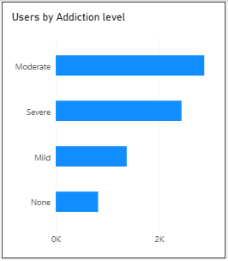

3. what is the proportion of addicted and non-addicted users?
- Visualization: Donut chart showing Addicted vs Non-addicted users.
- Screenshot of visualization:

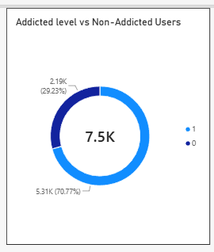

4. How does screen time vary across different age groups?
- Visualization: Column chart showing average daily screen time by age group.
- Screenshot of visualization:
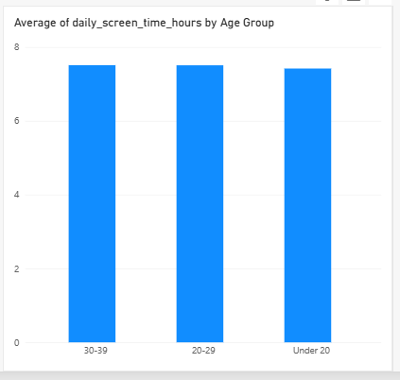
5. what is the relationship between screen time and sleep hours?
- Visualization: Scatter chart showing daily screen time and sleep hours for users.
- Screenshot of visualization:

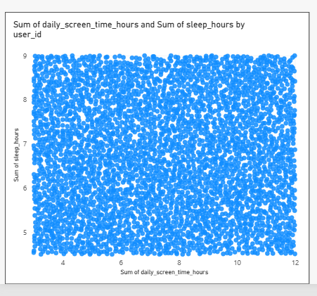

6. How do gaming hours compare with social media hours?
- Visualization: Column chart comparing average gaming hours and average social media hours.
- Screenshot of visualization:

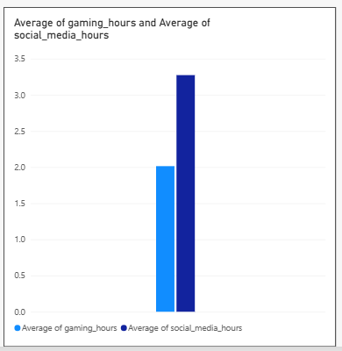

7. what is the average number of notifications received per day?
- Visualization: Card showing the average notifications received per day.
- Screenshot of visualization:

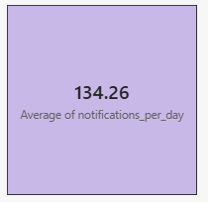

8. what are the average digital usage patterns of users?
- Visualization: KPI cards showing average screen time, social media hours, gaming hours, sleep hours, app opens and weekend screen time.
- Screenshot of visualization:

